# **Serenity Farm Equine Sanctuary**

# **Disaster and Emergency Evacuation Plan**

Disasters that can affect horses include fire, flood, earthquake, storm force winds (hurricanes and tornados), lightening, infectious diseases, drought, infectious diseases, and terrorist attack.

### Specific location disaster risks

#### Wildfire Risk Assessment

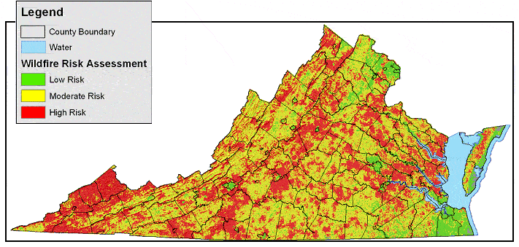VDOF has recently updated its Wildfire Risk Assessment to more objectively reflect the potential for wildfire across Virginia. Input layers include Slope, Aspect, Land cover, and Distance to Railroads, Distance to Roads, Population Density, and Historical Fire Occurrence. For more detailed information about modeling methodology, go to the GIS Data Downloads page and read the Info file (metadata) for the Wildfire Risk Assessment. SFES is at Moderate risk for Wildfire.

#### Flood **Assessment**

SFES property is classified as 200 year flood. The land has rolling hills and natural water draws. The creek is in the back of the property and has a 400% capability as identified on Louisa County Tax Maps.

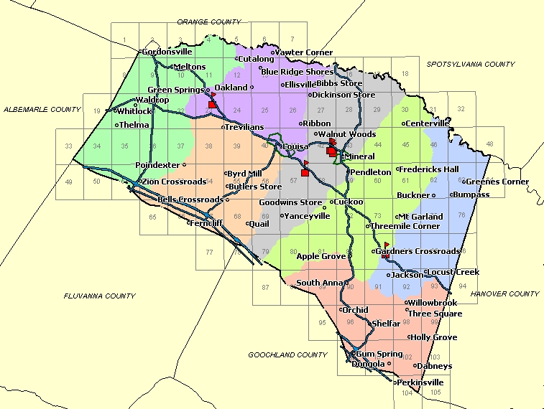

#### **Weather** **related events other than flood**

Louisa County is typically temperate with moderate fluctuations. (see chart) However, extremes include 4-6 days below 10 degrees and 4-6 weeks above 90 degrees. SFES utilizes compulsory shelter for wet days below 15 degrees. During higher temperatures, fans are available, however equine are free to utilize shade trees. When temperature is over 95, equine are monitored for excessive sweating and hydrated using electrolytes if needed.

#### **Earthquake Assessment**

While Louisa County experienced a 6.0 Earthquake in 2011, the probability of a significant repeat is 2.36%. We are considered a low risk area. Due to the 2011 event, increased monitoring and local emergency plans include earthquake preparation.

Even so, should an earthquake occur, all equine would be released to pasture. The greatest worry during an earthquake would be well damage. For this reason, SFES has applied for federal funds for a back-up well. We do not anticipate funding before 2017, but application has been made.

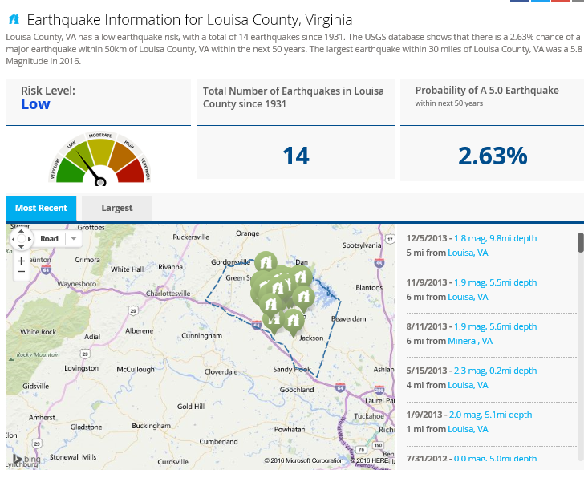

### Response Plan

1. Rhondavena or Bill LaPorte will determine if the situation requires emergency response and will oversee all action.
2. Cell phones will be available, and batteries are maintained. Further, emergency radios with emergency frequencies are on site as back up.
3. Emergency telephone numbers are posted (facility manager, fire, police, ambulance, veterinarian). This includes SFES address which is GPS friendly.
4. A medical profile, feed plan and general information for each equine is maintained in SFES database and located infeed room in print form.
5. The Virginia Equine release is utilized which includes EMS authorization for visitors and/or volunteers.
6. Multiple first aid kits (equine and people) are accessible and properly stocked at all times
7. Staff and volunteers are First Aid/CPR certified.
8. When a human injury occurs, an EAP will be activated immediately if the injured person:

* is not breathing.
* does not have a pulse.
* is bleeding profusely.
* has impaired consciousness.
* has injured the back, neck or head.
* has a visible major trauma to a limb **.**

1. When an equine injury occurs, an EAP will be activated immediately if the injured horse has:

* labored breathing
* Rapid or faint pulse
* is bleeding profusely.
* has impaired consciousness.
* has mobility issues.
* has a visible major trauma.

1. Severe Weather and Natural Disasters –

In most disasters, SFES equine will be released from buildings to well fenced pastures higher than flood area.

When necessary, evacuation plan will be initiated.

1. Fire

Smoke detectors will be utilized in tack and feed rooms. (note feed rooms do not house hay)

Fire Extinguishers are installed in barn and run-ins.

1. Supplies – The following emergency supplies (not limited to) are in stock at SFES.

* 50 foot cotton rope
* Battery or wind up portable radio
* Duct tape
* Multiple Fire extinguishers
* Flashlight with extra batteries and headlamps
* Ladder long enough to reach the barn roof in case of roof fire
* Rake for clearing vegetation and shovel for throwing dirt
* First-aid supplies for horses and humans
* Chain saw
* Hammer and nails
* Pry bar
* Materials for quick temporary fence repairs including fence ribbon and portable corrals
* Human First Aid Kits
* Tourniquet
* Plastic trash barrels with lids
* Sharp knife
* Wire cutters
* Tarps
* Lime and bleach
* Plywood (2’x4’) and can of spray paint
* 3 day supply of hay/grain/water
* Horse medication and instructions
* Clean towels
* Halters and leads
* Photos of each horse
* Equine first aid kit
* Animal marking paint
* Sheets/blankets
* Portable water/feed buckets
* Leg wraps and horse blankets

1. SFES Preparation

* All horses have tetanus toxoid, west Nile, equine encephalitis vaccinations vaccine within expiration dates with the exclusion of some of the feral horses who will be vaccinated as possible.
* All horses either are, or will be, trained to trailer load
* All horses have halters and leads at the paddock gates
* All structures have cleared perimeter areas.
* Roof surfaces and gutters are regularly cleaned.
* Neighbor (Perkins) has important contact and care information
* Large vehicles will be parked in open area when emergency imminent
* Electrical power can be terminated at one location for all buildings
* Plywood and spray paint is available for “have horses” signage
* Neighbors with fenced properties (Perkins and Bells) are identified as possible resource.
* Emergency Broadcast system available on portable radios and cells

1. Relocating horses

* Difficult to load horses will be loaded last.
* Horses that cannot be evacuated will be turned loose on the property
* Drivers are Bill LaPorte and +Rhondavena LaPorte
* Relocation – If appropriate, horses will be relocated to one of two nearby farms. If greater distance is required, assistance will be requested of CART (Crisis Animal Response Team) who has the ability to set up temporary shelter and corrals.
* Evacuation Emergency Information
  + Property owner – Bill and Rhondavena LaPorte
  + Property name – Serenity Farm Equine Sanctuary
  + Location – 2854 Byrd Mill Road
  + Phone number (540)842-1756
  + Number of equine at location
    - 6 Donkeys
    - 1 Mule
    - 3 Ponies
    - 24 horses
  + Number of trailers needed to evacuate in one trip 5 3-horse or 4 stock trailers
  + Types of trailers that can access property – Any size including 16-wheelers
  + Location of Trailer Turn around – large gravel area in front of hay barn
  + Will trailers need backing – Backing can be avoided.
* If owner is unavailable:
  + Veterinarian – Spotswood Veterinary
  + Name – Emily McNally
  + **Call or Text:** [(540) 300-8388](tel:5403008388)
  + **E-mail:** [contact@spotswoodvet.com](mailto:contact@spotswoodvet.com)
  + **Facebook message**: <https://www.facebook.com/spotswoodvet/>

### Emergency Action Plan

### Contact Information

Emergency phone numbers: 9-1-1 for all emergencies

Phone number: (540) 842-1756

Cell phone alternate: (540)748-6466

Address SFES:

2854 Byrd Mill Road

Louisa, VA 23093

### Address of nearest hospital:

Martha Jefferson Hospital

500 Martha Jefferson Drive  
Charlottesville, VA 22911

Phone number of nearest hospital 434-654-7000

Directions to nearest Hospital

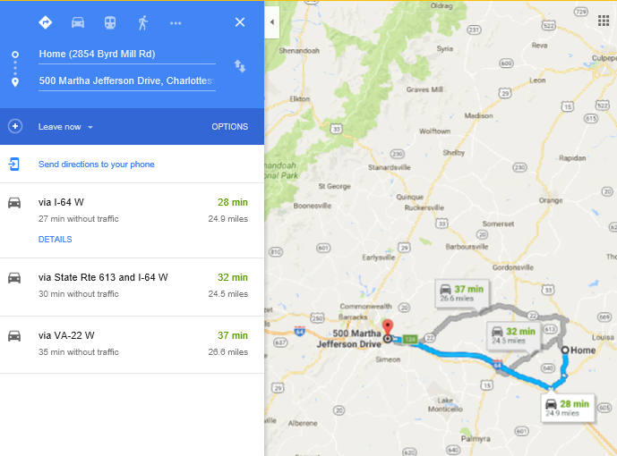

SFES contact (1st option): Rhondavena LaPorte

SFES contact (2nd option): Bill LaPorte

SFES contact (3rd option): TBA

**SERENITY FARM EQUINE SANCTUARY**

### HORSE EMERGENCY EVACUATION

**Scenario 1** – At least four (4) hours exist before a mandatory evacuation of people from the area is announced, allowing time to trailer horses to other locations.

**Scenario 2** – Sufficient time exists (1 to 4 hours) to put halters on all horses to ready them for evacuation or relocation to lower field.

**Scenario 3** – Insufficient time to organize horse evacuation or relocation and law enforcement requires all people to leave the area. Horses are to be turned loose on the ranch **(paddock gates, barn doors, and main property gates closed)** to allow horses to save themselves from impending blaze.

ASSUMPTION: This plan anticipates the ranch owners will be engaged in saving their belongings and dwellings will not be available to assist in horse evacuation, and the responsibility to fulfill this plan will reside with the boarders and other volunteers and attempt to perform the evacuation in good faith.

**SCENARIO 1 – 4 hours before mandatory evacuation**

NOTE: No horse trailers are to enter the property without permission from the owners or appropriate law enforcement personnel.

Loading coordinator: Person with most experienced in horse loading shall be the Loading Coordinator. Horse who knows how to load will be loaded first. The loading coordinator will consider the input of the horse owner and trailer owner, but is authorized to exercise his/her independent judgment, and if the horse will not load within a reasonable period, the next horse in line should be loaded and the problem horse returned to a holding pen until it can be safely loaded. In no event shall the loading of horses be unduly delayed for a problem horse because of limited space for trailers to wait to be loaded, and risk placed on people by the untrained horse.

Action #8 – If evacuation becomes **immediate**, revert to Scenario #2.

**SCENARIO 2 – 1-4 hours to evacuate/relocate horses, imminent evacuation**

There is insufficient time to evacuate all the horses via trailer, but mandatory evacuation required by law enforcement is imminent. All horses will be haltered and readied to be loaded into trailers and moved to the lower field if trailers are not available. Field gates will be closed, and water buckets hung if time allows.

**SCENARIO 3 – Immediate Evacuation**

Firestorm is imminent and law enforcement has ordered mandatory evacuation, or there is insufficient time to execute Scenario 1 or 2.

To the extent it is safe and authorized by appropriate law enforcement personnel, turn ALL horses loose, beginning with those closest to the fire. If possible, and it is safe to do so, herd the horses in the opposite direction of the fire. It is believed the horses will herd up and save themselves.

(NOTE: Be sure to securely close paddock gates and barn doors.)

PRE-EVACUATION FIRE SUPPRESSION

In no event should any person undertake any action that will place themselves or others at risk of injury. No person should attempt to operate a fire hose without training. No person should interfere with instructions of fire suppression personnel or other law enforcement authority.